  
BACS2003 ARTIFICIAL INTELLIGENCE

**202301 Session, Year 2022/23**

**Assignment Documentation**

| **Full Name: Chiew Hong Kuang** | |
| --- | --- |
| **Student ID:** | |
| **Programme: Bachelor of Computer Science (Honours) in Software Engineering** | |
| **Tutorial Class: G7** | |
| **Project Title:** | |
| **Module In-Charged:** | |
| **Other team members’ data**   | **No** | **Student Name** | **Module In Charge** | | --- | --- | --- | | **1** | **Kong Zhi Lin** | **User based + Content based** | | **2** | **Tan Eng Lip** | **User based + Item based** | | |
| **Lecturer:** | **Tutor :** |

# **Introduction**

## Problem Background

In this modernization and technology development era, many people are seeking spiritual wealth rather than physical wealth. As a result, people all over the world are now seeking and enjoying a variety of entertainments, such as movies, sports, anime, and video games, in order to unwind after a period of frustration. (<https://doi.org/10.53730/ijhs.v6nS2.8231>)

In this project, we will discuss Japanese animation (also called anime) which is a novel culture that is rising in recent years. It has been proposed that there is a problem in finding a proper anime recommender system on the market, as this has caused many people to be unable to find the proper anime suitable for them and thus lead to a lack of publicity for this wonderful culture (<https://doi.org/10.1109/ISRITI51436.2020.9315363>). Fortunately, we have proposed a solution to this problem by recommending to users high-rated anime that is relevant to their viewing preferences.

## Objectives/Aims

In this project, our primary objective and goal is to improve the user experience by providing personalized anime recommendations that are tailored to their interests and needs based on the anime they have watched previously. We also provide accurate searches among thousands of search results due to the anime recommended system that we have proposed being capable of producing a relevant and appropriate list of anime for the users. This allows users to find what they are looking for quickly and easily. This eventually can increase the users’ productivity, such as discovering new anime they were not familiar with before and also increased user engagement in the anime streaming platform.

Moreover, we are targeting to promote the anime culture as well as provide a great impression of anime to the users who are fresh to anime via this system since we will produce a list of anime to recommend based on the ratings in our dataset. As a result, the satisfaction of the users will be increased and eventually enhanced by providing personalized and high-quality recommendations instead of searching blindly and effortlessly.

## Motivation

> (legal system → legal content, security and privacy)

First and foremost, a successful recommender anime system can lead to sales and revenue increases for anime streaming platforms or publishers. An anime recommender system also can help increase revenue by promoting content that users are more likely to watch or rent/buy. This can also allow the user to explore their interests in various genres and push the views of animes that will help promote newer or less popular content, which can lead to increased revenue from rentals or purchases.

Besides that, by providing personalized anime content recommendations, a recommender system can increase user retention by making it more likely that users will continue using the video/anime streaming platform. This is because the recommendation meets the user's interest and makes them more likely to continue viewing the anime they are interested in. A recommender system that suggests anime titles based on their interests and viewing habits can help to guide them towards shows that they may enjoy, making it easier for them to become fans of the medium.

Therefore, our system can reduce the barrier to entry until it can help to expose users to a wider range of anime titles and genres, which can promote diversity and inclusivity in the anime community. For people who are new to the anime medium, the vast number of titles and genres can be overwhelming and intimidating. The recommender system also can recommend the popular anime at the moment and this can help to expand the anime fanbase and promote greater awareness and appreciation for the art form.

As a consequence, this can help to support the anime industry and encourage the production of more high-quality anime titles in the future by the preferences of the anime fans. Additionally, our system can help all the anime related companies to gather data for better understanding on user preferences and behaviors, which can inform content production and acquisition strategies.

## Timeline/Milestone

Our project duration started from … until … (.. Days)

## 

# **Research Background**

## Background of the applications

*Provide detailed explanations of the background of the application, e.g. machine learning algorithms, chatbot development, recommender system, sentiment analytic applications, robotic processing automation applications, image processing applications, etc.*

A recommender system is a subset or type of artificial intelligence (AI) technology that provides personalized recommendations to users based on their information such as past behaviors, preferences, and patterns. The objective of a recommender system is to suggest items or content that the user is probably to be interested in, based on their previous interactions with the system. As we know, recommender systems have been used in a wide range of applications, from e-commerce and online advertising to music, movie and item recommendations.

There are several different types of recommender systems, including content-based filtering, collaborative filtering, and hybrid recommender systems. Content-based filtering involves recommending items that are similar to items that the user has previously interacted with, based on their attributes or features. On the other hand, collaborative filtering involves recommending items based on the preferences and behaviors of other users who have similar interests to the user in question. Hybrid recommender systems combine elements of both content-based and collaborative filtering.

Additionally, recommender systems rely on a variety of techniques and algorithms to make recommendations. These may include data mining, machine learning, and natural language processing. In order to be effective, recommender systems require a large amount of data about user behaviors and preferences, as well as the items being recommended.

## Analysis of selected tool with any other relevant tools

*Fill the table below and change the tools’ names. You may add more columns.*

| **Tools comparison** | **Remark** | **Jupyter Notebook**  **(Python 3)** | **Visual Studio Code** | **Google Docs** | **Microsoft Excel (2019)** |
| --- | --- | --- | --- | --- | --- |
| Type of license and open source license | State all types of license | Open source | Free for private and commercial use. | Free for Google users. | Microsoft Office License required |
| Year founded | When is this tool being introduced? | 2014 | 2015 | 2006 | 1985 (oldest version of Excel) |
| Founding company | Owner | Fernando Pérez and Brian Granger | Microsoft Corporation | Upstartle | Microsoft Corporation |
| License Pricing | Compare the prices if the license is used for development and business/commercialization | None | Free | Free | None  (pre-install in laptop, so free for us) |
| Supported features | What features that it offers? | - enables user to run interactive python code  - markdown language supported | - enable users to manage the code with the support of various extensions.  - enable users to execute code in various file types such as python, c, java, ipynb etc.  - Enable connection to github for version control and collaboration. | - Act as a collaborative tool for cooperative editing of documents online  - Can be shared, opened, modified, download by multiple users simultaneously.  - Grammarly-check  - Spelling-check  - Can retrieve the history in order to get all version | - inserting a pivot table  - sorting of tabulated data  - adding formulas to the sheet to perform calculation  - visualize the data |
| Common applications | In what areas this tool is usually used? | - understanding the dataset loaded in  - perform data science tasks | - manage and execute the code for the development process. | - Allow users to collaborate editing the same documentation and also manage the version of the document. | - perform data analysis (by add-ins in Excel)  - calculate the budget of the project |
| Customer support | How the customer support is given, e.g. proprietary, online community, etc. | Open-source community | Microsoft support | Google | Microsoft support |
| Limitations | The drawbacks of the software | Buffer on kernel will affect running of the kernel and requires to restart all the kernel and run again. | Difficult to manage plugins when used for different programming environments. | Requires internet connection to collaborate with other people or access to the document. | It is difficult to detect fraud/corruption |

## Justify why the selected tool is suitable

*Explain which tool is used for the development, and justify the suitability of the tool used in your project.*

>

Visual Studio Code is the application we used in order to create the recommendation algorithm to predict the suitable result or recommendation to the users. Visual studio code supports multiple programming languages and it also includes .ipynb format which is the jupyter notebook. In visual studio code, it allows the use of various plugins that enable the functions such as code completion, error detection, etc which will save a lot of time rather than trial and error. Besides that, it also supports the import of libraries such as pandas, string, re, time etc. It is also a crucial feature which allows us to directly use the well developed function rather than needing to write the code from scratch.

Besides that, visual studio code also allows the collaboration with other teammates by using the git to commit, push and pull the latest code into github and the other teammate can make changes to the source code without any conflict. Github also has the version control features which allows us to find back the older version code committed on github and trace back who has made the changes.

# **Methodology**

## Description of dataset

The source of the dataset comes from Kaggle which is a website that provides various open source dataset. Our dataset is the “Anime Recommendations Database” (<https://www.kaggle.com/datasets/CooperUnion/anime-recommendations-database?select=anime.csv>) provided by a user called “COOPERUNION”. There are two files in this dataset which are Anime.csv and Rating.csv. This data set contains information on user preference data from 73,516 users on 12,294 anime. Each user is able to add anime to their completed list and give it a rating and this data set is a compilation of those ratings. Inside the anime.csv had 7 columns of variables about the information of anime movies which are anime_id, name, genre, type, episode, rating and members. There are 3 columns of variables of user rating which are user_id, anime_id and rating inside the rating.csv.

Anime.csv

| Numbering Column | | Description |
| --- | --- | --- |
| anime_id | | myanimelist.net's unique id identifying an anime. |

| Inputs/Features | Represent | Description |
| --- | --- | --- |
| name | Name | Full name of anime. |
| genre | Genre | Comma separated list of genres for this anime. |
| type | Type | Type of show such as movie, TV, OVA, etc |
| episodes | Episodes | The number of episodes in this show. (1 if movie). |
| rating | Rating | Average rating out of 10 for this anime. |
| members | Members | Number of community members that are in this anime's  "group". |

Rating.csv

| Numbering Column | | Description |
| --- | --- | --- |
| user_id | | Non identifiable randomly generated user id. |

| Inputs/Features | Represent | Description |
| --- | --- | --- |
| anime_id | Anime_id | The anime that this user has rated. |
| rating | Rating | Rating out of 10 this user has assigned (-1 if the user watched it but didn't assign a rating). |

NewRating.csv

### Data Preprocessing: Data Transformation

There are some variables belonging to improper data types in the anime.csv such as the data type of name, genre, type and episodes belongs to object while the name, genre and type should belong to string type and the episodes belong to int64. Figure 3.1.1 below shows the original data type of the variables in the anime.csv while the Figure 3.1.2 shows the output after applying astype() method in pandas to convert the data type of the variables. Data transformation is necessary and important since the algorithm that is used for generating the recommended system is sensitive to the type and format of data.

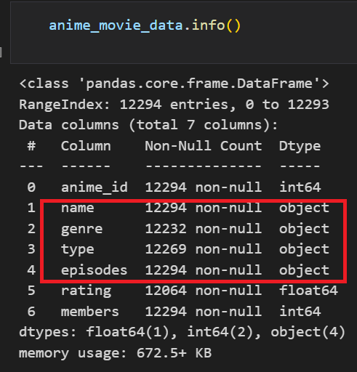

Figure 3.1.1 Before Data Transformation

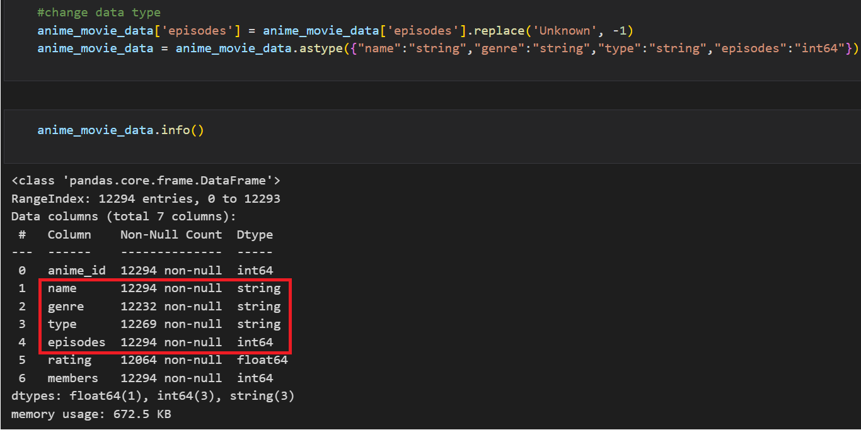

Figure 3.1.2 After Data Transformation by Using ‘astype()’

### Meaningful Variable Name

1. rating

The column label of ‘rating’ appears at both the anime.csv and rating.csv but the meaning of ‘rating’ is different from each other. The ‘rating’ in the anime.csv means the average rating for each anime movie that is rated by the users while the ‘rating’ in the rating.csv means the user rating for each anime they had viewed. Therefore, there must be a modification on the variable name in order to reduce the confusion of the label. Figure 3.1.4 shows the original label of the anime.csv while Figure 3.1.5 shows the modified label of the anime.csv. Figure 3.1.6 shows the original label of the rating.csv and Figure 3.1.7 shows the modified label of the rating.csv.

‘rating’ in the anime.csv changes to ‘avg_rating’

‘rating’ in the rating.csv changes to ‘user_rating’

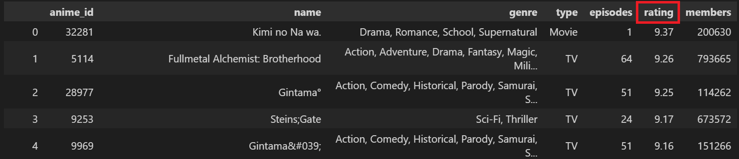

Figure 3.1.4 Original data frame of anime.csv with ‘rating’ label

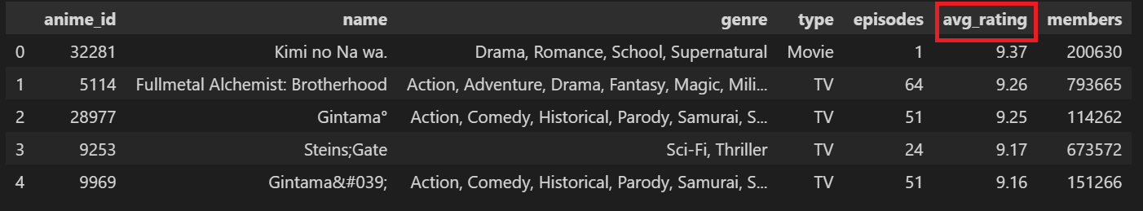

Figure 3.1.5 Modified data frame of anime.csv with ‘avg_rating’ label

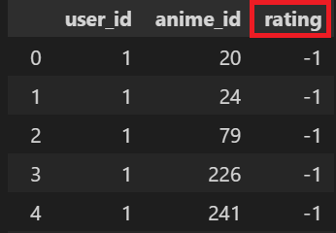

Figure 3.1.6 Original data frame of rating.csv with ‘rating’ label

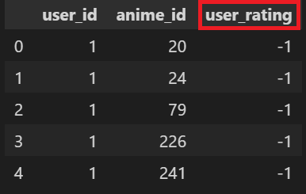

Figure 3.1.6 Original data frame of rating.csv with ‘rating’ label

## Applications of the algorithm(s)

*Describe how the selected algorithm(s) or technique(s) is used in your project.*

>

### 

## System flowchart/activity diagram

*Draw a simple diagram to illustrate the system design/data flow*

>

## Proposed test plan/hypothesis

*Design a simple test plan or state the hypothesis that you want to test in the project*

>

# **Result**

## Results

*Demonstrate the results based on the test plan/hypothesis / print screen*

>

## Discussion/Interpretation

*Critically discuss the results and interpret the implications*

>

# **Discussion and Conclusion**

## Achievements

*Discuss what the project has achieved and state whether it has fulfilled the objectives*

>

## Limitations and Future Works

## *Discuss the limitations of the project and what improvements can be done in the future*

>

## 

# **Reference & Source**

## *Provide the sources of the dataset and tool(s) used for development*

## *List the articles or other references you have cited in the text using the Harvard Referencing system.*

## 

# 

# 

# 